

**AMERICAN INTERNATIONAL UNIVERSITY-BANGLADESH**

**DIGITAL LOGIC DESIGN LABORATORY**

**Experiment No:** 03

**Section:** B

**Semester:** Fall 2021-22

**Experiment Name: Derive logic equations and truth table from combinational circuits.**

**Submitted by: Md Saiful Islam**

## Submitted to: Dr. Ferdous Jahan Shaun

## Date of Experiment: 27-September-2021

## Date of Submission: 04-October-2021

**Group No: C**

|  |  |  |  |
| --- | --- | --- | --- |
| **SL NO** | **NAME** | **ID** | **Department** |
| 1 | Rishad, Md. Yashir Arafat | 18-37677-1 | CSE |
| 2 | Pushan, Mahathir Shams | 18-37220-1 | CSE |
| 3 | Md Saiful Islam | 18-36363-1 | CSE |
| 4 | Sadek Islam | 17-35436-3 | CSE |
| 5 | Izu, Humam Ahmed | 17-34148-1 | CSE |
| 6 | Moktadir, Md. Golam | 18-37211-1 | CSE |
| 7 | Sunny, Fazle Rabbi | 16-32822-3 | CSSE |
| 8 | Pritom, Sadi Mohammed | 18-37236-1 | CSE |
| 9 | Rasel,Md. AMINUL | 18-37723-1 | CSE |

1. **Abstract:**

Deriving logic equations and truth table from combinational circuits is very important. Because of that’s we can easily detecting the output logic expressions from any unknown logic circuit. The truth tables is derived from the logic expressions by the logic circuit. Expressions are simplified and efficient way to using Boolean algebra and De Morgan's law to reduce the number of gates used. The main goal of this experiment is to learn how to derive logic equations and truth table from combinational circuits.

1. **Objective:**
   1. Derive logic equation and truth table from combinational circuits.
   2. To learn the properties of universal gates.
   3. To put inputs and outputs to the test.
2. **Results:**
   1. Simulation Environment: Proteus Professional Software version 8.9 was utilized to simulate this assignment. 2D circuits can be constructed with this simulation software.
   2. Simulation Results:

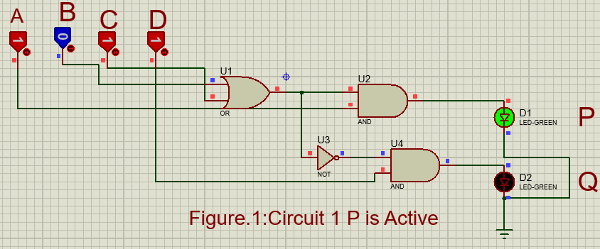

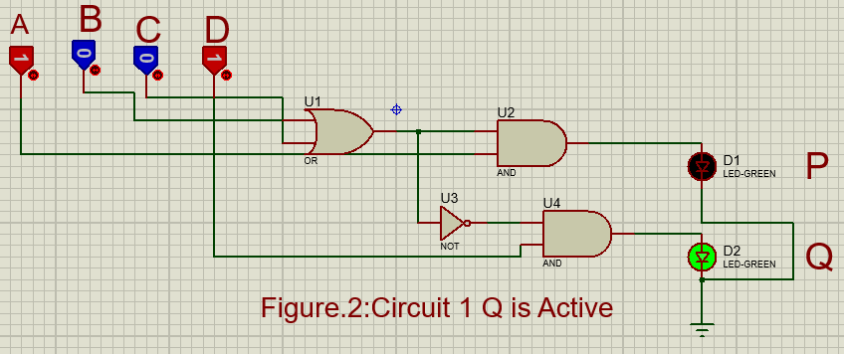

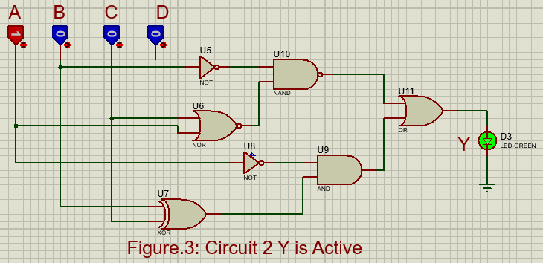

* 1. **Discussion:**

The main purpose of this experiment is to Derive logic equations and truth table from combinational circuits. By analysing theoretical and practical data it can be very easy way to run the experiment successful without any major error. Pin connections for all the ICs were studied. All the connections were carefully made to avoid errors. The voltage supply was switched off during the implementation. Finally, the experiment was successful by Deriving logic equations and truth table from combinational circuits.

1. **Questions for report writing:**
2. Constructed the derived equations by using Universal gates (both NAND and NOR) is given below:

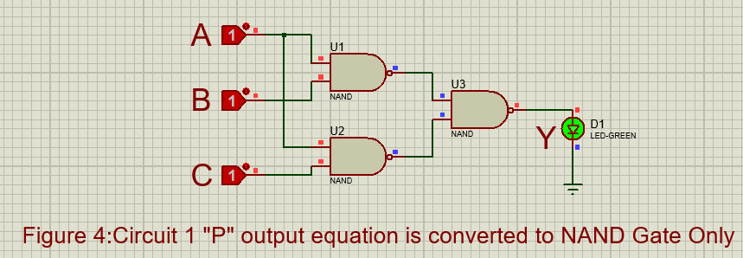

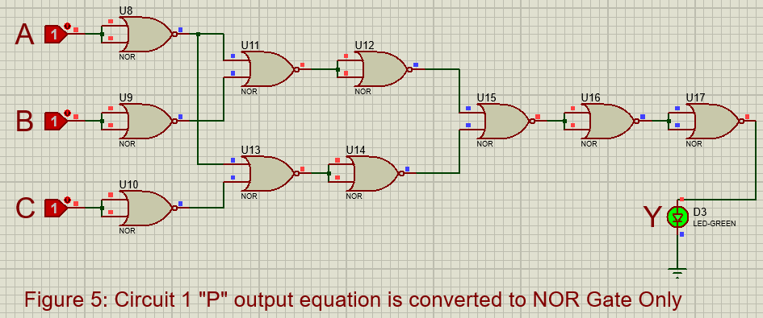

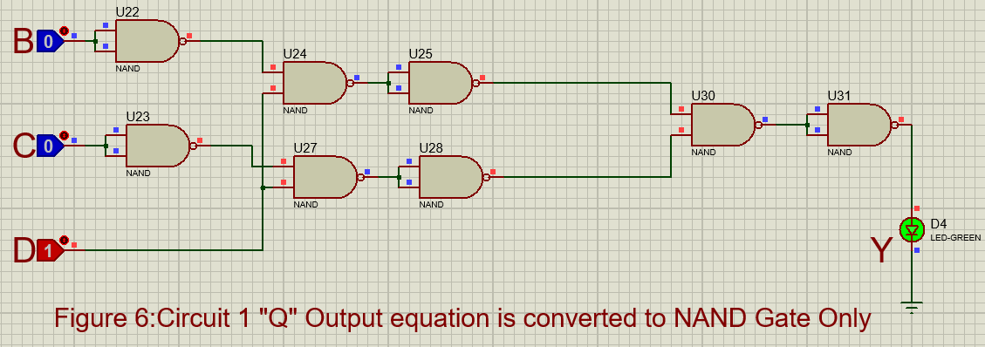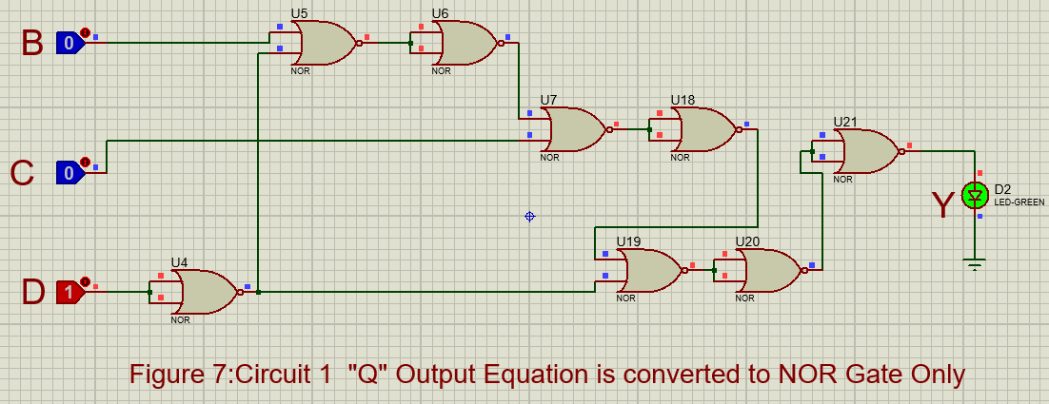

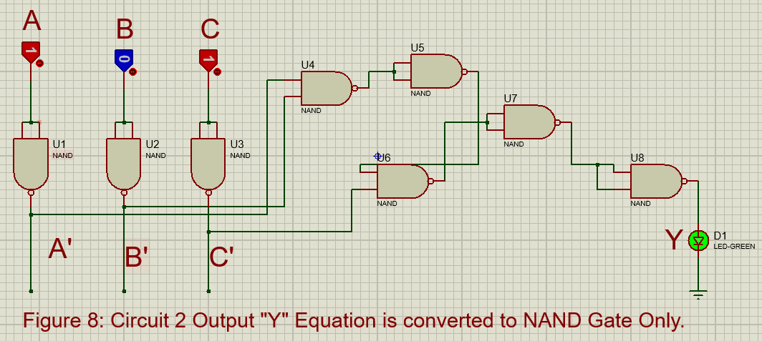

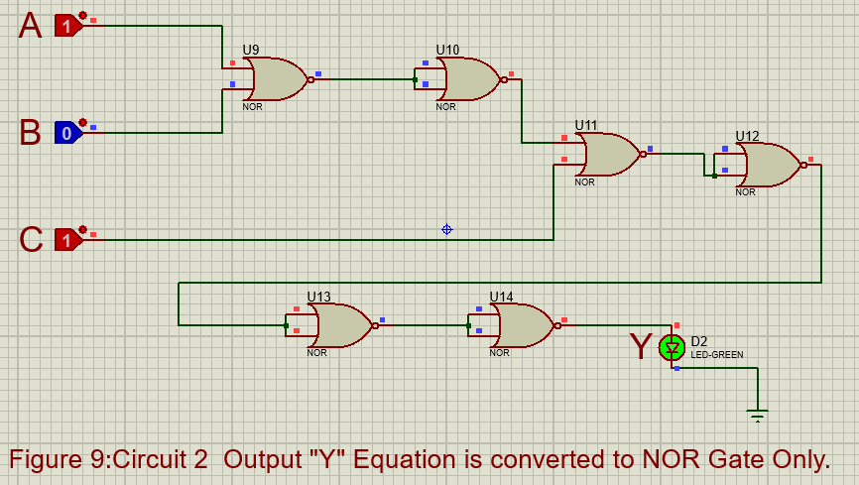

1. **Conclusion**:

This experiment is run successful all the Derive logic equations and truth table from combinational circuits. All of the tests were completed successfully. This experiment is aided in a better understanding of the combinational circuits.

**Reference:**

1. “Digital Fundamentals” by Thomas L. Floyd
2. American International University- Bangladesh’’ Digital Logic Design Laboratory

experiment 3 Laboratory Manual”.